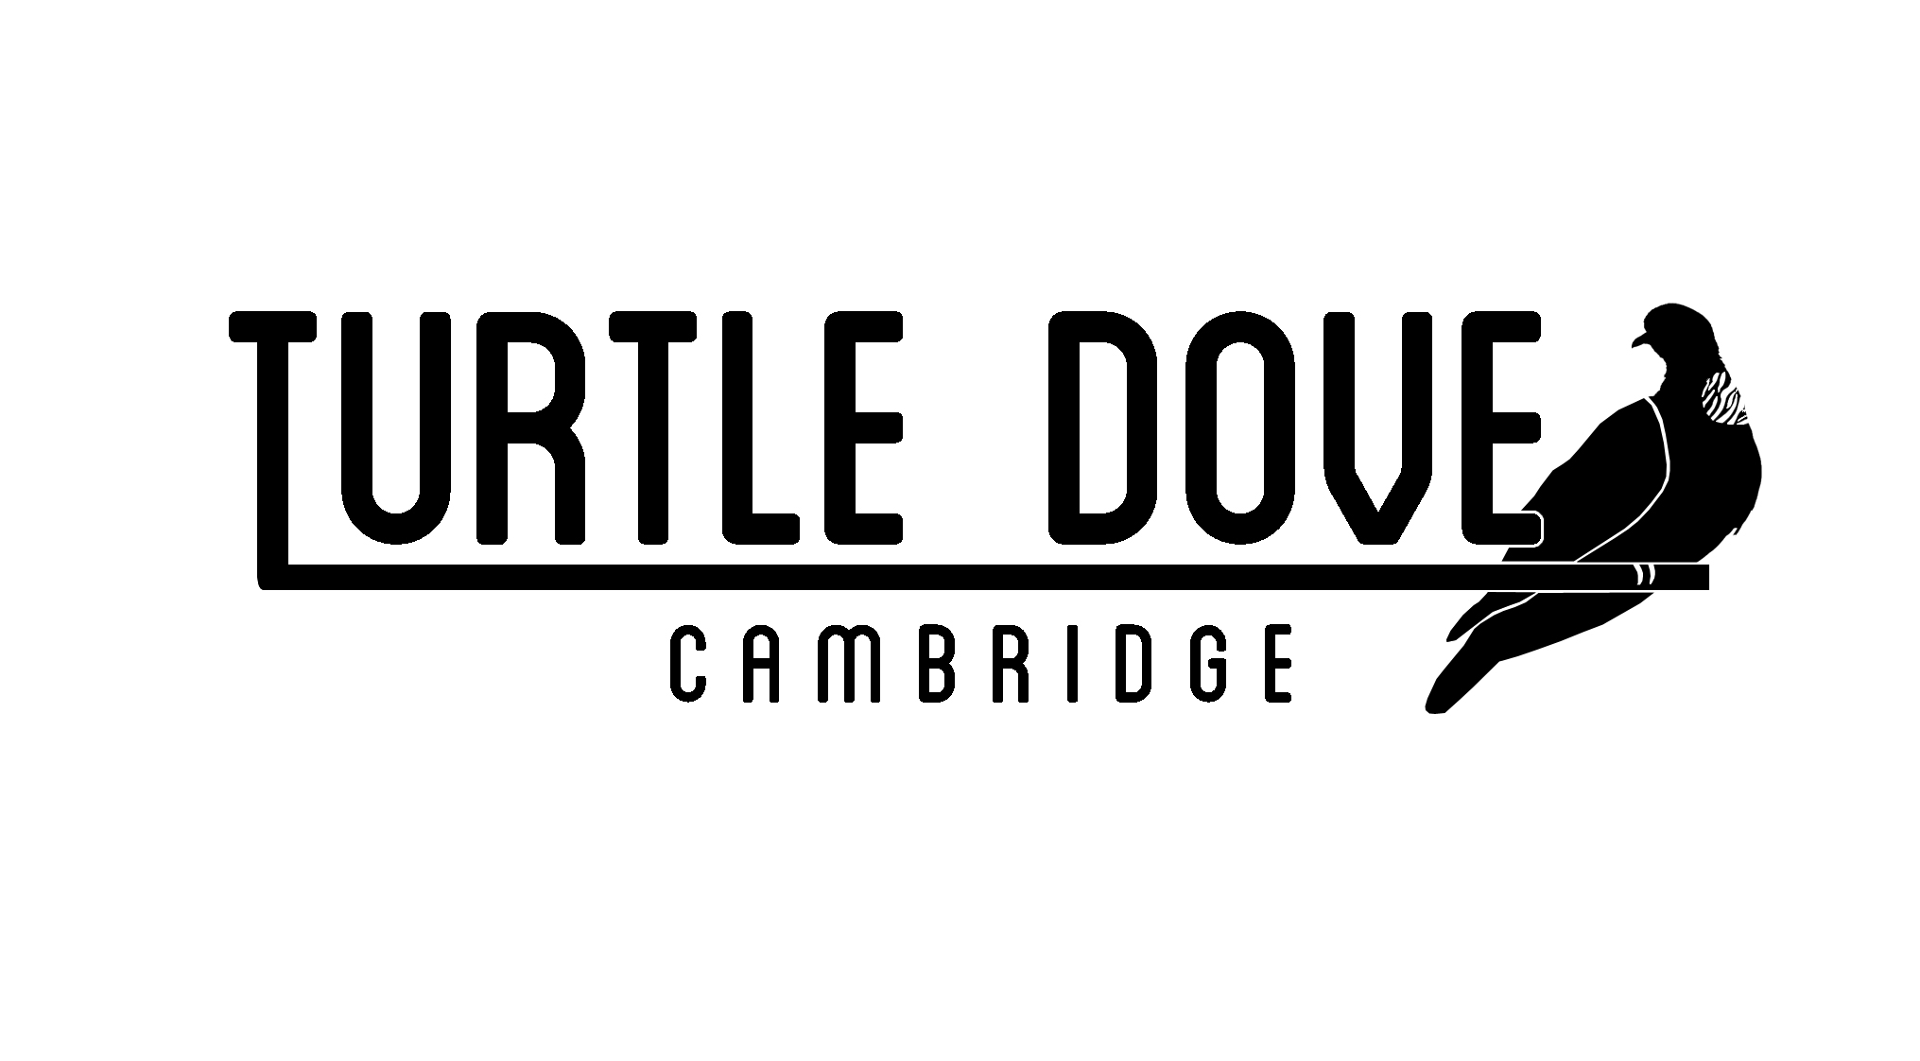

**Turtle Dove Cambridge Community Interest Company**

**Social Media Policy**

**Reviewed: March 2025**

**Review due: March 2026**

**Purpose and Scope**

This policy covers all forms of social media, including Facebook, LinkedIn, TikTok, Instagram, Wikipedia, other social networking sites, and other internet postings, including blogs.

It applies to the use of social media for both business and personal purposes, during working hours and in your own time to the extent that it may affect the business and reputation of TDC.

The policy applies both when the social media is accessed using our Information Systems and also when access using equipment or software belonging to employees or others.

Whilst we recognise the benefits which may be gained from appropriate use of social media, it is also important to be aware that it poses significant risks to our organisation. These risks include disclosure of confidential information and intellectual property, damage to our reputation and the risk of legal claims.

To minimise these risks this policy sets out the rules applying to the use of social media.

This policy covers all employees and volunteers.

Breach of this policy may result in disciplinary action up to and including dismissal.

Any misuse of social media should be reported to the Managing Director.

This policy is not contractual, and we may amend it at any time if it considers it appropriate to do so.

**Personal use of social media at work**

We allow staff to make occasional personal use of social media at work so long as it does not involve unprofessional or inappropriate content and does not adversely affect your productivity or otherwise interfere with your duties to Turtle Dove Cambridge (TDC).

Any use must comply with this policy. We may monitor your use of our systems, including use of social media sites.

Business use of social media, if you are required or permitted to use social media sites in the course of performing your duties for or on behalf of TDC, you should ensure that such use has appropriate authorisation and that it complies with the standards set out in this policy.

**Responsible use of social media**

You must not use social media in a way that might breach any of TDC’s policies, any express or implied contractual obligations, legislation, or regulatory requirements.

In particular, use of social media must comply with:

* the Equal Opportunities and Bullying and Harassment Policies;
* rules of relevant regulatory bodies;
* contractual confidentiality requirements;
* the Safeguarding Policy.

In your use of social media, you must not:

* make disparaging or defamatory statements about us, our employees, our volunteers, clients, customers, or suppliers;
* harass, bully or unlawfully discriminate in any way;
* use data obtained in the course of your employment with us in any way which breaches the provisions of GDPR and any other data protection legislation;
* breach copyright belonging to us;
* disclose any intellectual property, confidential or commercially sensitive information relating to our business;
* make statements which cause, or may cause, harm to our reputation or otherwise be prejudicial to our interests.

You should avoid using social media communications that might be misconstrued in a way that could damage our reputation or that of our partners.

You should make it clear in personal postings that you are speaking on your own behalf, in particular write in the first person and use a personal e-mail address.

If you disclose that you are an employee of TDC, you must state that your views do not represent those of your employer. For example, you could state, “the views in this posting do not represent the views of my employer”.

Remember that you are personally responsible for what you communicate in social media. Often materials published will be widely accessible by the public and will remain accessible for a long time. If you are uncertain or concerned about the appropriateness of any statement or posting, you should discuss it with your manager before making the post.

The contact details of business contacts made during the course of your employment are regarded as confidential information belonging to TDC. On termination of your employment, you must provide us with a copy of all such information, delete all such details from your personal social networking accounts and destroy any further copies of such information that you may have.